

Information Technology Project – IT2080

Batch 04

Group No – TP_WD_B04_G01

Agile Activity Report

Tourism and Travel Management System

|  |  |  |  |  |
| --- | --- | --- | --- | --- |
|  | **Name with Initials** | **Registration Number** | **Contact Phone Number** | **Email** |
|  | Thuduvage I.M.H.G | IT21169380 | 0771886641 | isurusanka98@gmail.com |
|  | Madusanka G.K.I | IT21189944 | 0766859740 | Isharamadusanka410@gmail.com |
|  | Ekanayaka E.M.D.K.L | IT21186042 | 0703248686 | it21186042@my.sliit.lk |
|  | Kodithuwakku C.K. | IT21156960 | 0786714662 | chamith227@gmail.com |
|  | Arandara S.D. | IT21164330 | 0779920805 | It21164330@my.sliit.lk |
|  | Karunarathne R.Y.D. | IT21169144 | 0788095559 | it21169144@my.sliit.lk |
|  | Navindi R.L.S. | IT21166174 | 0770507538 | navilokumanage@gmail.com |
|  | Sumanasekara W.H.U. | IT21184444 | 0719963107 | sumanasekaraupamali@gmail.com |

Contents

Project Introduction 3

Relative Estimate: 4

1.Thuduvage I.M.H.G 5

2. Madusanka G.K.I 7

3. Ekanayaka E.M.D.K.L 9

4. Kodithuwakku C.K 11

5. Arandara S.D 13

6. Karunarathne R.Y.D 15

7. Navindi R.L.S 17

8. Sumanasekara W.H.U 18

Product Backlog 20

Sprint Backlog 25

Kanban Board 27

References 28

# Project Introduction

Innovative startup Travely has created a thorough travel and tourist management system that is intended to make booking and managing travel simple, convenient, and hassle-free. Travellers may easily organize their excursions with the use of a system called Travely, which provides a wealth of features and services. Any traveler needs to be able to book hotels, rental cars, restaurants, events, tour packages, and customized tours, which are all included in Travely's travel and tourism management system. Travelers may quickly organize their trip without having to traverse through several websites or interact with multiple service providers thanks to the availability of these features on a single platform.

The Travely system also features a one-stop shop website where travelers may arrange their whole journey. With the help of this tool, travelers may choose the places they wish to go, make trip plans, and reserve all the services they'll need in one spot. Also, the system offers comprehensive details about every location, including nearby eateries, activities, and events. Each tourist will have a customized experience thanks to Travely's travel and tourism management system. Travelers can easily identify what they need and swiftly and easily book their services because of the system's ease of use and user friendliness. The system is also built to give travelers access to the most recent information while making travel arrangements by giving real-time availability and pricing information.

In summary, Travely's travel and tourism management system offers an all-inclusive and cuttingedge approach to planning and managing travel. It's the ideal platform for travelers who wish to properly plan their trip and take pleasure in a stress-free travel experience thanks to its all-in-one services web page and personalized approach.

# Relative Estimate:

**Fibonacci Method**

Fibonacci method is a mathematical pattern in which each number is the sum of two preceding numbers. The sequence starts with 0 and 1, and subsequent number is the sum of previous two numbers. The sequence goes like 0,1,2,3,5,8,13,21.

In agile estimation, the Fibonacci sequence is used as a scale for relative estimation of the user story.

The scale is exponential, meaning that the difference in effort between a 2-point task and a 3-point task is not the same as the difference between a 3-point task and a 5-point task. For example, a 3-point task might be estimated to take three times as much effort as a 1-point task, while an 8-point task might be estimated to take eight times as much effort as a 1-point task. [1]

# 1.Thuduvage I.M.H.G

**Epic: User and Admin Management System for Travely**

**Feature 1:**

* User registration

**User Story**

As a user, I want to be able to register for an account with Travely so that I can access travel and tourism services.

**Task Breakdown**

* Set up a registration form with the required fields and user types.
* Validate user input on the server side to prevent invalid entries.
* Store user information in a secure database
* Make the Email the unique user ID for each new registration.
* Send a confirmation email to verify the user's email address.

**Feature 2:**

* Authentication
* User account management

**User Story**

As a user, I want to be able to log in to my Travely account securely so that I can access my bookings and travel plans.

**Task Breakdown**

* Create a login form with email and password fields.
* Authenticate user credentials against the database.
* Generate a JSON Web Token (JWT) upon successful authentication.
* Store the JWT on the client side.
* Use the JWT to authorize access to protected routes.

**User Story**

As a user, I want to be able to edit my account information on Travely.

**Task Breakdown**

* Create an account settings page with editable fields.
* Validate user input on the server side to prevent invalid entries.
* Update user information in the database
* Send email confirmation of changes.

**User Story**

As a user, I want to be able to reset my password if I forget it.

**Task Breakdown**

* Create a password reset page with an email field.
* Send an OTP to the Email to verify the user.
* After verifying the OTP, redirect the user to a page to enter a new password.

Send email confirmation of changes.

**User Story**

As a user, I want to be able to reset my password if I forget it.

**Task Breakdown**

* Create a password reset page with an email field.

Send an OTP to the Email to verify the user.

* After verifying the OTP, redirect the user to a page to enter a new password.

Send email confirmation of changes.

**Feature 3:**

* Role-Based access control

**User Story**

As an admin, I want to be able to assign roles and permissions to users.

**Task Breakdown**

* Create a user roles page in the admin dashboard.
* Add the ability to assign roles and permissions to users.
* Update the database to store user roles and permissions.
* Implement role-based access control for protected routes.

**Feature 4:**

* User search and filtering

**User Story**

As an admin, I want to be able to search and filter user accounts based on specific criteria.

**Task Breakdown**

* Create a user search page in the admin dashboard.
* Add search and filter options (e.g., name, registration date, account status)
* Update the database query to filter based on selected criteria.
* Display search results to the admin user.

# 2. Madusanka G.K.I

**Epic: Tour Package Management**

**Feature 1:**

* Create Tour Package

**User Story**

As a tour guide, I want to be able to create a new tour package, so that I can offer it to my customers

**Task Breakdown**

* Create a form to get details about tour package.
* Upload images to tour package.
* Store data in database.

.

**User Story**

As a tour guide, I want to be able to edit an existing tour package, so that I can update package details.

**Task Breakdown**

* Create a form to get details about tour package.
* Upload images to tour package.
* update data from database.

**User Story**

As a tour guide, I want to be able to delete a tour package, so that I can remove unwanted packages from tour packages.

**Task Breakdown**

* Add a delete button to the tour package details.
* Implement deleting feature.

**Feature 2:**

* Book a Tour Package

**User Story**

As a tour manager I want to be able to view all bookings and booking requests for a particular tour package, so that I can manage them.

**Task Breakdown**

* Create booking form for customers to fill.
* Store details from customers to database

**User Story**

As a customer, I want to be able to customize a tour package by adding or removing features from the given customizable tour package, so that I can find something that suits my schedule and budget.

**Task Breakdown**

* Determine features that can be add or remove.
* .Develop a customizable tour package system.
* Test and debug the system.

**User Story**

As a tourist , I need reservation invoice report so that I can confirm reservation when visit to the hotel.

**Task Breakdown**

* Develop a functionality that generates reservation invoices.
* Integrate the invoice generation functionality with the database management system.
* Design and implement the user interface for accessing and downloading reservation invoices.

**Feature 3:**

* Tour package reviews

**User Story**

As a customer I want to be able add a review for a tour package, so that I can share my experience with others.

**Task Breakdown**

* Add a review form for tour packages.
* Save data to database.
* Display average rating by considering all reviews according to tour packages.

**User Story**

As a tour manager I want to be able to view all reviews for a particular tour package, so that I can manage them.

**Task Breakdown**

* Add a review manage page .
* Implement feature to view all reviews and add or delete them to website .

# 3. Ekanayaka E.M.D.K.L

**Epic 1: Financial management system**

**Feature 1:**

* Finance Management

**User Story**

As the customer, I want to request a refund so that I can get payment back.

As the Finance manager of the company, I want to check refund requests from clients if they are under our company’s refund policies so that I can confirm them.

As the finance manager of the company, I want to create a balance in a particular time frame for the company so that I can provide the current situation of the company.

As the finance manager of the company, I want to calculate the salaries for the employees so that I can provide what the HR Department asked for.

**Task Breakdown**

* Implement interfaces.
* Implement form to request for refunds to enter their information.
* Implement to calculate balance for time.
* Implement function to filter expenses.
* Implement function to calculate salaries.
* Create balance sheets.
* Error handling

**Feature 2:**

* Analyzing data and generating reports

**User Story**

As the finance manager of the company, I want to analyse data so that I can generate reports.

**Task Breakdown**

* Implement to interfaces to analyze data.
* Implement function to filter information (salary , expenses , etc.)
* Fetch data from the database for relevant conditions
* Implement function to analyze data as manager wants.
* Create balance sheets.
* Error handling

**Feature 2:**

* Analyzing data and generating reports

**User Story**

As the finance manager of the company, I want to analyse data so that I can generate reports.

**Task Breakdown**

* Implement to interfaces to analyze data.
* Implement function to filter information (salary , expenses , etc.)
* Fetch data from the database for relevant conditions
* Implement function to analyze data as manager wants.
* Create balance sheets.
* Error handling

**Epic 2: Create an inquiry management system.**

**Feature 1:**

* Customer relationship management.

**User Story**

As the Inquiry manager of the company, I want to answer the customer's questions on time.

As the Inquiry manager of the company, I want to be able to assign inquiries to the Inquiry management team so that efficiency can be improved.

As the Inquiry manager of the company, I want to track the status of the inquiries so that I can ensure they are resolved in a timely manner.

As the customer, I want to receive a message acknowledging my inquiry so that I know it has been received.

**Task Breakdown**

* Implement form to input inquiries.
* Implement functions to assign inquiries.
* Implement function to update and track the status.
* Create Live chat to respond on time.
* Error handling

**Feature 2:**

* Analysing reports.

**User Story**

As the Inquiry manager of the company, I want to analyse data and generate reports.

**Task Breakdown**

* Implement interface to generate reports.
* Implement function to filter information.
* Generate expenses and profits for several conditions.

# 4. Kodithuwakku C.K

**Epic: Create a financial management system**

**Feature 1:**

* Manage reservations.

**User Story**

As the Residence Manager of the company, I need information of the registered hotels to review the hotels before adding to the system.

**Task Breakdown**

* Design the resident manager user interface.
* Export hotel information from database.
* Implement hotel verification function for residence manager.

**User Story**

As a hotel owner, I need to add hotel the system so that I can market my hotels.

**Task Breakdown**

* Design the user interface for hotel owner dashboard.
* Create form to add hotels.
* Connect backend to the form.
* Import hotel details to the database.

**User Story**

As the Residence Manager, I need approved hotel report so that I can get decision about inappropriate hotels.

**Task Breakdown**

* Create hotel review function.
* Integrate the hotel review function with the database management system.
* Design user interface for hotel review.

**User Story**

As a hotel owner, I need to update rooms availability so that tourist can book rooms according to the room’s availability.

**Task Breakdown**

* Create function for update rooms availability.
* Integrate that function with the database management system.

**User Story**

As a hotel owner, I need to view reservation list so that I can review reservations.

**Task Breakdown**

* Create function for update rooms availability.
* Implement function for display the reservation list.
* Develop user interface for display the reservation list.

**Feature 2:**

* **Manage tourist resident services**.

**User Story**

As a tourist, I need to search hotels by filter location so that I can select hotel according to my preferences.

**Task Breakdown**

* Develop a search functionality that allows users to filter hotels by location.
* Integrate the search functionality with the database management system.
* Develop a functionality that allows users to check room availability for a particular hotel and date.

**User Story**

As a tourist, I need to check availability of the hotel rooms so that I can book hotel rooms.

**Task Breakdown**

* Integrate the availability check functionality with the database management system.
* Design and implement the user interface for checking room availability.

**User Story**

As a tourist , I need reservation invoice report so that I can confirm reservation when visit to the hotel.

**Task Breakdown**

* Develop a functionality that generates reservation invoices.
* Integrate the invoice generation functionality with the database management system.
* Design and implement the user interface for accessing and downloading reservation invoices.

# 5. Arandara S.D

**Epic: Flight/Train Ticket booking system**

**Feature 1:**

* Book a flight/Train Ticket.

**User Story**

As a tourist, I want to search for available flight/Train based on my travel dates, time, and the destination so that I can book ticket as I want.

**Task Breakdown**

* Create a search form for tourists to display available flight/train.
* Implement a search function to display available flights/trains.
* Implement filters (example:-prices ,airline ,train service ,arrival time)
* Error handling

**User Story**

As a tourists, I want to view flight/train booking reviews before booking so that I can select best flight

**Task Breakdown**

* Implement page details for each train and flight.
* Display the information of flight and trains.
* Implement function to search flight / trains.
* Implement error handling.

**User Story**

As a tourist, I want to book flight/train ticket and receive a confirmation (3)

**Task Breakdown**

* Implement a booking form for users to enter inputs.
* Connect this for payment gateway to take payment.
* Send a confirm email to user store it in database.

**Feature 2:**

* Manage Booking.

**User Story**

As a tourist, I want view my current and past flight/train bookings so that I can get an idea about my tours

**Task Breakdown**

* Create dashboard for users.
* Implement a search function for filter.
* Display key information.
* Error handling

**User Story**

As a tourist, I want to cancel or modify a booking so that I can change my ticket as I wish.

**Task Breakdown**

* Implement a cancellation/ edit form for tourists.
* Validate user inputs.
* Implement function for refund.
* Send confirm email.

**Feature 3:**

* Admin panel

**User Story**

As a flight/train booking manager, I want to manage flight/train options and prices (3)

**Task Breakdown**

* Create interface to add/edit/delete flight/train options.
* implement a pricing system based on factors such as time of year , demand, and the availability.
* error handling

**User Story**

As a Admin , I want to view and manage all booking so that I can get idea about the booking

**Task Breakdown**

* Create an interface for admin to view and filter booking.
* Implement functions for filtering.
* Implement the function to cancel or edit bookings on behalf of users.
* Error handling

# 6. Karunarathne R.Y.D

**Epic: Create a Vehicle Management System**

**Feature 1:**

* **Add a vehicle to the system**.

**User Story**

As a vehicle owner I want to be able to add a vehicle to the system. So that, I can rent my vehicles through the system.

**Task Breakdown**

* Create a form.
* Create databases.
* Create a database connection with the form.
* Send form data to the database once the submit button is clicked.
* Add validations to check whether the required fields are filled or not.

**User Story**

As a vehicle owner I want to be able to update the options like available dates of the vehicle and pricing. So that Customer can easily reserve a vehicle.

**Task Breakdown**

* Create the form edit function.
* Retrieve data from database and show them on the form.
* Update details once the update button is clicked.

**User Story**

As a vehicle owner of the system, I want to be able to delete vehicle from the system so that I can remove my vehicle from the system if anything happens like if I must sell my vehicle.

**Task Breakdown**

* Create a function to retrieve and list down “my vehicles.”
* add delete button and create function to delete vehicle once the delete button is clicked.
* Display pop up message to make sure that vehicle owner is really wanting to delete the vehicle from the system.

**User Story**

As a vehicle owner I want to be able to download the monthly vehicle reservation details of my vehicle, so that I can monitor data like data of people who reserved my vehicle, where it went and make predictions about my next month’s revenue.

**Task Breakdown**

* Implement a function to retrieve all the reservations from the database and calculate the monthly reservations.
* Implement a function to generate and download the calculated amount as a PDF.

**Feature 2:**

* **Reserve a Vehicle**.

**User Story**

As a Customer, I want to reserve a vehicle based on the vehicle type, location, date, and price, so that I can choose the one that best suits to my needs.

**Task Breakdown**

* Implement a function to show the available vehicles on the screen.
* Implement a function to filter vehicles based on the location, vehicle type, date.
* create function to reserve vehicle.

**User Story**

As a customer, I want to be able to cancel my reservation so that I do not have to pay for a rental that I will not use.

**Task Breakdown**

* Create functions to retrieve “my reservations”.
* Add popup message to re-confirm the cancellation.
* Implement a function to delete the reservation once the user confirmed.

**User Story**

As a customer I want to be able to download the reservation details report of my reservation so that I can monitor my trip details.

**Task Breakdown**

* Implement a function to retrieve the reservation details of the customer.
* Implement a function to generate and download the reservation report as a PDF.

**Feature 2:**

* **Vehicle management**

**User Story**

As a Vehicle Manager, I want to be able to review vehicles and submit or reject them so that I can ensure the system meets customer demand.

**Task Breakdown**

* Create a connection with vehicle database and retrieve the added vehicle information.
* Create a function to display all the information of the pending approval vehicles.
* Create a function to click one of the vehicles in the list and display all the information regarding the vehicle.
* Implement a function to accept/decline the vehicle from the system.

# 7. Navindi R.L.S

**Epic**: **Create Restaurant Management System**

**Feature 1:**

* Add restaurant to the system.

**User Story**

As a restaurant owner I need to add my restaurant to the Travely system. So that I can approach tourist customer base and promote my restaurant through the system.

**Task Breakdown**

* Create a form.
* Create a database.
* Add validations to check whether the required fields are filled and correct data types are entered.

**User Story**

As a restaurant owner I want be able to update the reservation details of the available tables so that a customer can easily reserve a table via the system.

**Task Breakdown**

* Create the form “Edit” function.
* Retrieve previous submitted data form and display them on the current form.
* Update the details once the “Save Changes” button is clicked.

**User Story**

As a restaurant owner I want be able to delete my restaurant from the system if any situation occurred such as restaurant is closed due to a considerable reason.

**Task Breakdown**

* Create a function to delete the restaurant from the system.
* Add “Delete Restaurant” option to delete restaurant once the button is clicked.

# 8. Sumanasekara W.H.U

**Epic**: **Special Activity Management**

**Feature 1:**

* customers can view activity details.
* customers can search special activities.
* customers can filter special activities using many features like location and price range.

**User Story**

As a user, I want to be able to browse for special activities by location, date, time, and price, so that I can find something that suits my schedule and budget.(18)

**Task Breakdown**

* Retrieve details of special activities from the database.
* Implement filter to sort special activities based on customer preferences.
* Implement search function to allow user to find specific activity by keyword.
* Write test case to ensure in function special activity browsing feature and perform through testing before releasing the feature.

**Feature 2:**

* customers can view activity details.
* customers can search special activities.
* customers can filter special activities using many features like location and price range.

**User Story**

As a user, I want to be able to reserve a place for a special activity, so that I can ensure my participation.

**Task Breakdown**

* Get customer details by form.
* Store customer booking details

**Feature 3:**

* View special activities.

**User Story**

As a user, I want to be able to view details about the special activity, such as the required instruments, the duration, and any special instructions, so that I can come prepared

**Task Breakdown**

* Implement interfaces to view all special activity.
* Implement function to search events.
* implement function to filter.
* error handling

**Feature 4:**

* Manage special events.

.

**User Story**

As a user, I want to be able to leave feedback and ratings on special activities, so that other users can benefit from my experience (8)

**Task Breakdown**

* Implement to view all activities.
* Implement search and filter events.
* Implement forms to enter reviews.
* Connect these entered information.

**User Story**

As a special activity manager, I want to be able to add, edit, and remove special activities, so that I can keep the list up to date. (8)

**Task Breakdown**

* Implement to page to manage special events.
* Implement function to search and filter events.
* Implement form to edit/add event details.
* Implement features to delete events.
* Error handling

# Product Backlog

**Priority Scale**

1 - Highest Priority

2 - Normal Priority

3 - Less Priority

|  |  |  |  |
| --- | --- | --- | --- |
| priority | ID | User Story | Relative estimate |
| 1 | 0011 | As a user, I want to be able to register for an account with Travely so that I can access travel and tourism services. | 5 |
| 1 | 0012 | As a user, I want to be able to log in to my Travely account securely so that I can access my bookings and travel plans. | 8 |
| 1 | 0013 | As a user, I want to be able to edit my account information on Travely. | 5 |
| 2 | 0014 | As a user, I want to be able to reset my password if I forget it | 5 |
| 3 | 0015 | As an admin, I want to be able to delete user accounts | 3 |
| 1 | 0016 | As an admin, I want to be able to assign roles and permissions to users | 8 |
| 3 | 0017 | As an admin, I want to be able to search and filter user accounts based on specific criteria. | 5 |
| 1 | 0111 | As a tour guide, I want to be able to create a new tour package, so that I can offer it to my customers | 5 |
| 1 | 0112 | As a tour guide, I want to be able to edit an existing tour package, so that I can update package details | 3 |
| 3 | 0113 | As a tour guide, I want to be able to delete a tour package, so that I can remove unwanted packages from tour packages | 2 |
| 2 | 0114 | As a tour manager I want to be able to view all bookings and booking requests for a particular tour package, so that I can manage them | 8 |
| 1 | 0115 | As a customer I want to be able to book a tour package, so that I can enjoy my vacation | 5 |
| 2 | 0116 | As a customer I want to be able add a review for a tour package, so that I can share my experience with others | 7 |
| 1 | 0117 | As a tour manager I want to be able to view all reviews for a particular tour package, so that I can manage them | 5 |
| 2 | 0118 | As a customer, I want to be able to customize a tour package by adding or removing features from the given customizable tour package, so that I can find something that suits my schedule and budget | 3 |
| 3 | 1111 | As a tourist, I need reservation invoice report so that I can confirm reservation when visit to the hotel. | 2 |
| 1 | 1112 | As a tourist, I need to check availability of the hotel rooms so that I can book hotel rooms. | 8 |
| 3 | 1113 | As a tourist, I need to search hotels by filter location so that I can select hotel according to my preferences. | 5 |
| 2 | 1114 | As a hotel owner, I need to view reservation list so that I can review reservations. | 5 |
| 2 | 1115 | As a hotel owner, I need to update rooms availability so that tourist can book rooms according to the room’s availability. | 3 |
| 3 | 1116 | As the Residence Manager, I need approved hotel report so that I can get decision about inappropriate hotels. | 8 |
| 1 | 1117 | As a hotel owner, I need to add hotel the system so that I can market my hotels. | 5 |
| 1 | 1118 | As the Residence Manager of the company, I need information of the registered hotels to review the hotels before adding to the system. | 2 |
| 1 | 2111 | As the Inquiry manager of the company, I want to analyze data and generate reports | 5 |
| 1 | 2112 | As the customer, I want to request a refund so that I can get payment back. | 3 |
| 1 | 2113 | As the Finance manager of the company, I want to check refund requests from clients if they are under our company’s refund policies so that I can confirm them. | 5 |
| 2 | 2114 | As the finance manager of the company, I want to create a balance sheet in a particular time frame for the company so that I can provide the current situation of the company. | 5 |
| 1 | 2115 | As the finance manager of the company, I want to calculate the salaries for the employees so that I can provide what the HR Department asked for | 13 |
| 2 | 2116 | As the finance manager of the company, I want to analyze data so that I can generate reports | 5 |
| 1 | 2117 | As the Inquiry manager of the company, I want to be able to assign inquiries to the Inquiry management team so that efficiency can be improved | 3 |
| 2 | 2118 | As the Inquiry manager of the company, I want to track the status of the inquiries so that I can ensure they are resolved in a timely manner | 8 |
| 3 | 2119 | As the customer, I want to receive a message acknowledging my inquiry so that I know it has been received. | 3 |
| 1 | 2120 | As the Inquiry manager of the company, I want to answer the customer's questions on time | 5 |
| 2 | 3111 | As a vehicle owner I want to be able to update the options like available dates of the vehicle and pricing. So that Customer can easily reserve a vehicle. | 5 |
| 1 | 3112 | As a vehicle owner I want to be able to add a vehicle to the system. So that, I can rent my vehicles through the system. | 8 |
| 1 | 3113 | As a vehicle owner of the system, I want to be able to delete vehicle from the system so that I can remove my vehicle from the system if anything happens like if I must sell my vehicle. | 3 |
| 3 | 3114 | As a vehicle owner I want to be able to download the monthly vehicle reservation details of my vehicle, so that I can monitor data like data of people who reserved my vehicle, where it went and make predictions about my next month’s revenue. | 5 |
| 1 | 3115 | As a Customer, I want to reserve a vehicle based on the vehicle type, location, date, and price, so that I can choose the one that best suits to my needs. | 8 |
| 1 | 3116 | As a customer, I want to be able to cancel my reservation so that I do not have to pay for a rental that I will not use. | 3 |
| 3 | 3117 | As a customer I want to be able to download the reservation details report of my reservation so that I can monitor my trip details. | 3 |
| 1 | 3118 | As a Vehicle Manager, I want to be able to review vehicles and submit or reject them so that I can ensure the system meets customer demand. | 5 |
| 3 | 4111 | As a tourist, I want to view flight/train booking reviews before booking so that I can select best flight | 3 |
| 1 | 4112 | As a tourist, I want to search for available flight/Train based on my travel dates, time, and the destination so that I can book ticket as I want | 5 |
| 1 | 4113 | As a tourist, I want to book flight/train ticket and receive a confirmation | 8 |
| 1 | 4114 | As a tourist, I want to view my current and past flight/train bookings so that I can get an idea about my tours | 5 |
| 2 | 4115 | As a tourist, I want to cancel or modify a booking so that I can change my ticket as I wish | 3 |
| 2 | 4116 | As an Admin, I want to view and manage all booking so that I can get idea about the booking | 5 |
| 3 | 4117 | As a flight/train booking manager, I want to manage flight/train options and prices | 8 |
| 1 | 5111 | As a restaurant manager I need to add restaurants to the system after an inquiry process so I can maintain the standard of our services. | 13 |
| 3 | 5112 | As a restaurant manager I need to generate a monthly report so that I can have a clear idea about that restaurant and take future decisions for the welfare of the system (based on customer ratings and feedbacks). | 5 |
| 1 | 5113 | As a restaurant manager need to add, retrieve, update, and delete restaurant details that I can manage restaurants in the system. | 8 |
| 2 | 5114 | As a restaurant manager I need to delete reservation details from the database if any cancellation occurred so I can retrieve only the efficient and accurate data that I want. | 5 |
| 1 | 5115 | As a customer I need to make a reservation for a restaurant. | 8 |
| 1 | 5116 | As a customer I need to cancel a reservation as I wish. | 3 |
| 3 | 5117 | As a customer I need to give a feedback and rate the restaurant for the service that is provided by the restaurant. | 3 |
| 1 | 6111 | As a user, I want to be able to browse for special activities by location, date, time, and price, so that I can find something that suits my schedule and budget | 5 |
| 1 | 6112 | As a user, I want to be able to reserve a place for a special activity, so that I can ensure my participation. | 3 |
| 2 | 6113 | As a user, I want to be able to view details about the special activity, such as the required instruments, the duration, and any special instructions, so that I can come prepared. | 8 |
| 3 | 6114 | As a user, I want to be able to leave feedback and ratings on special activities, so that other users can benefit from my experience. | 5 |
| 1 | 6115 | As a special activity manager, I want to be able to add, edit, and remove special activities, so that I can keep the list up to date. | 3 |
| 3 | 6116 | As a special activity manager, I want to be able to generate reports on special activity enrollment, so that I can make informed decisions about scheduling and resource allocation | 5 |
| 2 | 6117 | As a special activity manager, I want to be able to view and handle reservations for special activities, so that I can ensure smooth operations. | 3 |
| 2 | 6118 | As a user, I want to be able to search for special activities by location, date, time, and price, so that I can find something that suits my schedule and budget. | 5 |

Link For Product Backlog - <https://app.clickup.com/9007066276/v/s/90070201995>

# Sprint Backlog

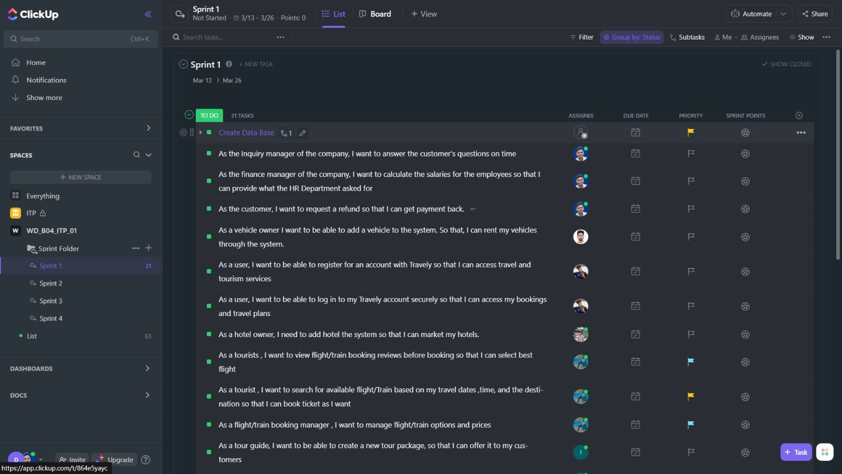

|  |  |  |
| --- | --- | --- |
| Backlog Item | ID | User Story |
| All Systems | 0001 | Create Data Base |
| User Management System | 0011 | As a user, I want to be able to register for an account with Travely so that I can access travel and tourism services. |
| User Management System | 0012 | As a user, I want to be able to log in to my Travely account securely so that I can access my bookings and travel plans. |
| Finance and Inquiry management System | 2120 | As the Inquiry manager of the company, I want to answer the customer's questions on time |
| Finance and Inquiry management System | 2115 | As the finance manager of the company, I want to calculate the salaries for the employees so that I can provide what the HR Department asked for |
| Finance and Inquiry management System | 2112 | As the customer, I want to request a refund so that I can get payment back. |
| Vehicle Reservation Management System | 3112 | As a vehicle owner I want to be able to add a vehicle to the system. So that, I can rent my vehicles through the system. |
| Residence Reservation Management System | 1117 | As a hotel owner, I need to add hotels to the system so that I can market my hotels. |
| Flight and Train Booking Management System | 4111 | As a tourist, I want to view flight/train booking reviews before booking so that I can select the best flight. |
| Flight and Train Booking Management System | 4112 | As a tourist, I want to search for an available flight/Train based on my travel dates, time, and the destination so that I can book ticket as I want. |
| Flight and Train Booking Management System | 4114 | As a flight/train booking manager, I want to manage flight/train options and prices. |
| Tour packages Management System | 0111 | As a tour guide, I want to be able to create a new tour package, so that I can offer it to my customers. |
| Tour packages Management System | 0115 | As a customer I want to be able to book a tour package, so that I can enjoy my vacation. |
| Tour packages Management System | 0118 | As a customer, I want to be able to customize a tour package by adding or removing features from the given customizable tour package, so that I can find something that suits my schedule and budget. |
| Residence Reservation Management System | 1118 | As the Residence Manager of the company, I need information about the registered hotels to review the hotels before adding to the system. |
| Vehicle Reservation Management System | 3113 | As a vehicle owner of the system, I want to be able to delete vehicles from the system so that I can remove my vehicle from the system if anything happens, like if I must sell my vehicle. |
| Special activity Management System | 6115 | As a special activity manager, I want to be able to add, edit, and remove special activities, so that I can keep the list up to date. |
| Special activity Management System | 6112 | As a user, I want to be able to reserve a place for a special activity, so that I can ensure my participation. |
| Restaurant Management System | 5111 | As a restaurant manager I need to add restaurants to the system after an inquiry process so I can maintain the standard of our services. |
| Restaurant Management System | 5112 | As a restaurant manager I need to generate a monthly report so that I can have a clear idea about that restaurant and take future decisions for the welfare of the system (based on customer ratings and feedback). |
| Restaurant Management System | 5113 | As a restaurant manager need to add, retrieve, update, and delete restaurant details that I can manage restaurants in the system. |

1st Sprint - <https://app.clickup.com/9007066276/v/l/6-900701077016-1>

# Kanban Board

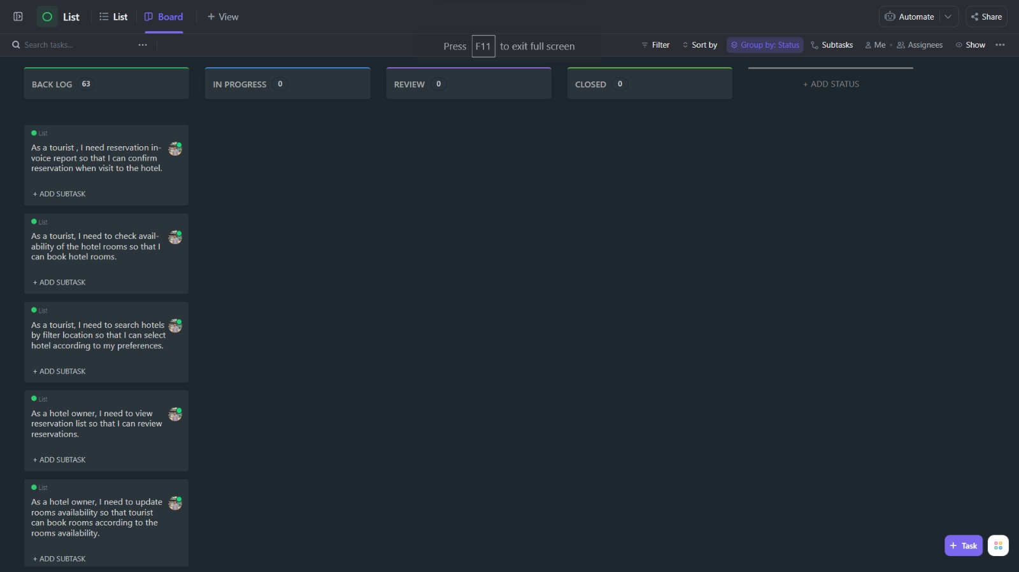

# References

|  |  |
| --- | --- |
| [1] | “Fibonacci sequence:,” [Online]. Available: https://mathworld.wolfram.com/FibonacciSequence.html. |